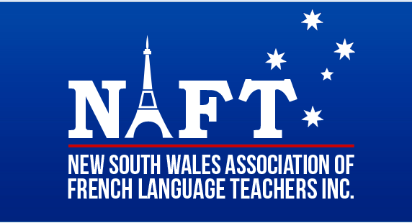

YEAR 12 Speaking SKILLS DAY : 5th JUNE 2021: 4 venues

Important information about the very helpful NAFT speaking skills day for NSW HSC French students at Beginners, Continuers and Extension levels.
There will be 4 Speaking days in Term 2

The 4 venues on June 5 are at:

•WENONA SCHOOL North Sydney -CONTINUERS & EXTENSION - Organiser Ross Millar

•KAMBALA SCHOOL Vaucluse- CONTINUERS & EXTENSION - Organiser Marion Rosen

• MERCY COLLEGE Chatswood - BEGINNERS & CONTINUERS - Organiser Charmaine Forbes
• CASTLE HILL HIGH- CONTINUERS, BEGINNERS & EXTENSION - Organiser: Lara Palma

Plus :

In Term 3 a Speaking day will be held on July 17 at
• BURWOOD GIRLS HIGH SCHOOL– CONTINUERS & BEGINNERS -Organiser Michael Anthony and you can start registering for this event too.
closing date for this event only ( July 7)

Please start your process for attendance ASAP by getting permission letters and excursion forms ready for your classes by referring to the costs and registration details which will be on the NAFT Home page by this Saturday.
Log into NAFT with your login at www.naft.org.au
Look for the Speaking day venue that best meets your needs under: UPCOMING EVENTS on the right-hand side of the page. Click on the link for more information to download all the information for the venue.

CLOSING DATE : June 1

Under NO circumstances are students to be ever given passwords or access to the NAFT website.
Payment must come via the member and the school, following the registration procedure on the NAFT website.

Please be exact when completing your registration including your name and school address & the numbers of students attending for each level. Do NOT register student names.

ALL SCHOOLS! : to guarantee your attendance, please ensure that you have started payment requests ASAP.

NB Invoices can be generated when you register the numbers of your students for each level and go to the payment details page.

merci d'avance,
Annabel Gassmann and Bev Wilkinson
president@naft.org.au

NOTE:

In Term 2
- Another event might be held on the Central Coast- Central Coast Grammar- Date TBC
Organiser: Elsa Ribal-Vigneau: Contact: elsa.ribalvigneau@ccgs.nsw.edu.au

