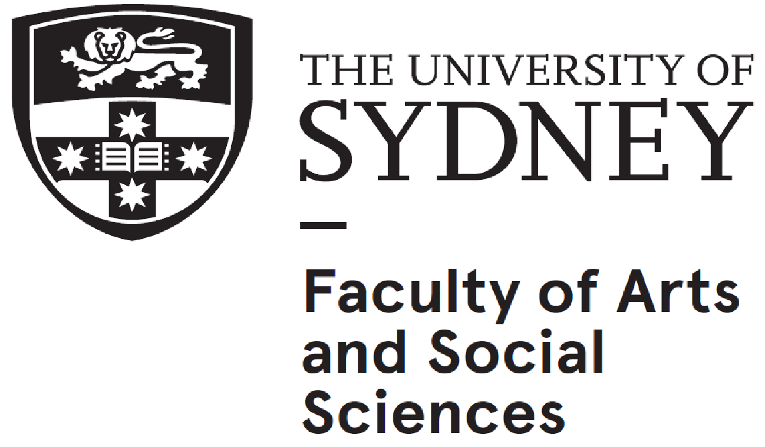

**YEAR 12 STUDY SKILLS DAY – PROGRAMME & INFORMATION**

**SATURDAY 29th May 2021 @Sydney University - CONT (8:30-12:00); BEG (8:30-12:00); EXT (12:15-3:00)**

|  |  |  |
| --- | --- | --- |
| **SESSION / EXAM SECTION** | **TIME** | **PRESENTER** |
| **Registration CONTINUERS**  **Registration BEGINNERS**  **Registration EXTENSION** | **8:30 – 9:00am**  **8:30- 9:00am**  **12.15 – 12.30pm** | Mary-Anne Bianchin, Jacquie Hilmer, Bev Wilkinson |
| **CONTINUERS – ABS AUDITORIUM B2010, Abercrombie Business School Building** | | |
| **Enter room** | **9:00** |  |
| **Welcome** | 9:10 | Annabel Gassmann |
| Listening and Responding | 9:15 – 9:45 | Melinda Rundle |
| Reading and Responding (A & B) | 9:45 – 10:15 | Trent Wilson |
| Post-school Study of French | 10:15 – 10:30 | Dr. Carolyn Stott |
| ***PAUSE CAFE 10:30 – 10:50AM*** | | |
| Speaking | 10:55 - 11:25 | Françoise Reeves-Smith |
| Writing in French | 11:25 – 11:55 | Stella Holmes |
| **Conclusion - Thanks / Evaluation** | 11:55 – 12:00 | Annabel Gassmann |
| ***DEJEUNER 12:00-12:30***  **BEGINNERS – ABS LECTURE THEATRE 1110, Abercrombie Business School Building** | | |
| **Enter room** | **09.00** |  |
| **Welcome** | 09.10 | Bev Wilkinson |
| Post-school Study of French | 09.15 – 9.30 | Dr. Carolyn Stott |
| Writing Skills | 09:30 – 10:00 | TBC |
| Speaking Skills | 10:00 - 10:30 | TBC |
| ***PAUSE CAFÉ 10:30 – 10:50AM*** | | |
| Listening and Responding | 10:55 – 11:25 | Sheila Ibarra |
| Reading and Responding | 11:25 – 11:55 | Emma Quan |
| **Conclusion – Thanks / Evaluation** | 11:55 – 12:00 | Bev Wilkinson |
| ***FIN***  **EXTENSION – ABS CASE STUDY LECT THEATRE 1050, Abercrombie Business School Building** | | |
| **Enter Room** | **12:30** |  |
| **Welcome** | **12:40** | Jacquie Hilmer |
| Prescribed text – Part A | 12:45 – 1:15 | Karen Downes |
| Prescribed text – Part B | 1:15 – 1:45 | Jacquie Hilmer |
| Speaking skills | 1:45 – 2:15 | Karen Downes |
| Writing in French | 2:15 – 2:45 | Audrey Roby |
| **Conclusion – Thanks / Evaluation** | 2:45– 3:00 | Jacquie Hilmer |

Please note presentations are subject to last minute changes.

Presentations on each section of exam to run for 30 mins max.(incl. questions)