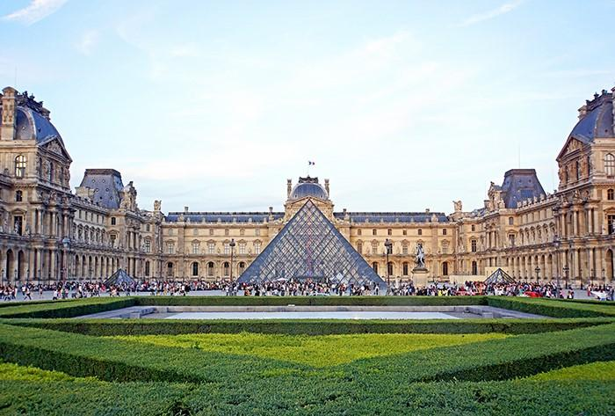
NSW French Teachers’ Association HSC Study Day
Hosted by the Faculty of Arts and Social Sciences
Saturday, 29th May 2021
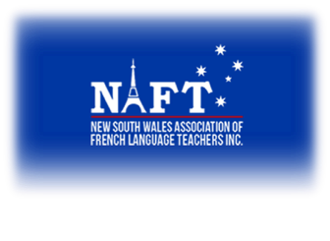

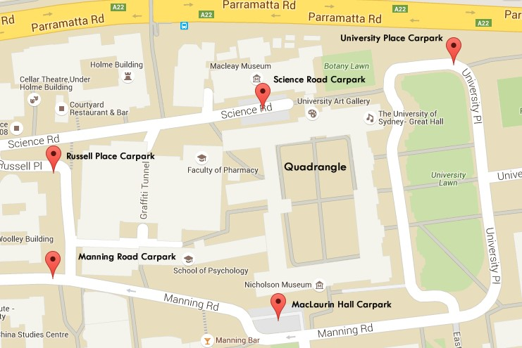

Getting There

The Abercrombie Business School (ABS) at the University of Sydney is located on the corner of Abercrombie and Codrington Streets, Darlington.

The ABS is approximately 10 minutes walk from Redfern Station. As you leave Redfern Station, turn left and head down Lawson Street and then continue onto Abercrombie Street until you reach Codrington Street – the ABS is located at the roundabout on the corner of Abercrombie and Codrington
Streets. Alternatively, you can catch a bus from Railway Square at Central Station, and travel along City Road towards Newtown. You will need to depart the bus at the corner of Butlin Avenue and City Road, and walk approximately 4 minutes to the ABS.

Parking on Campus

There are several carparks located on campus. Parking is approximately $2 per hour on Saturdays up to a maximum $6 flat rate for the day.
Alternatively, you can park on Abercrombie Street and surrounding streets. However, restrictions apply and the respective parking signs should be referred to for the most up-to-date parking rates, hours and restrictions.

Room Locations
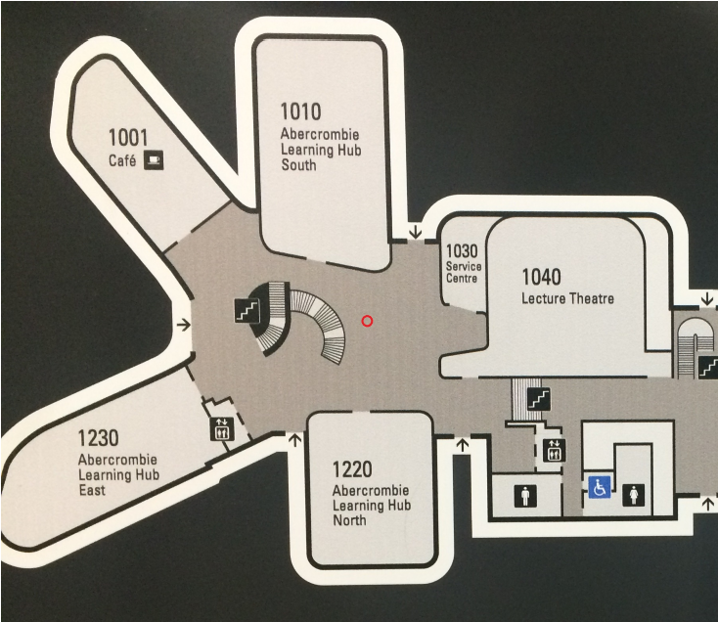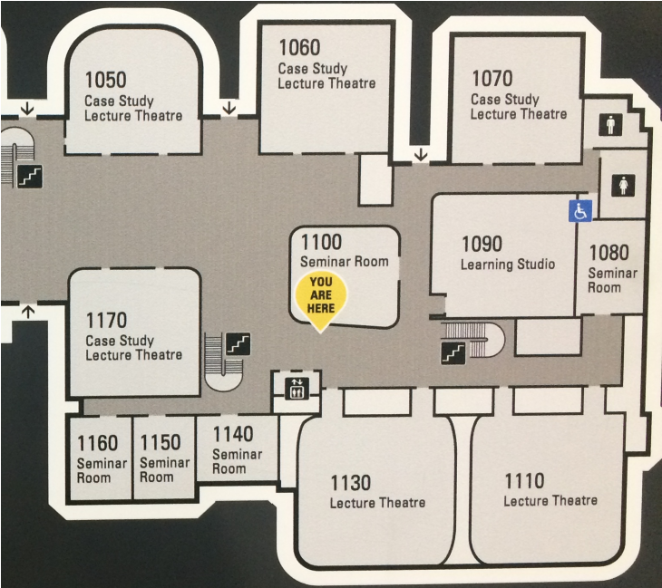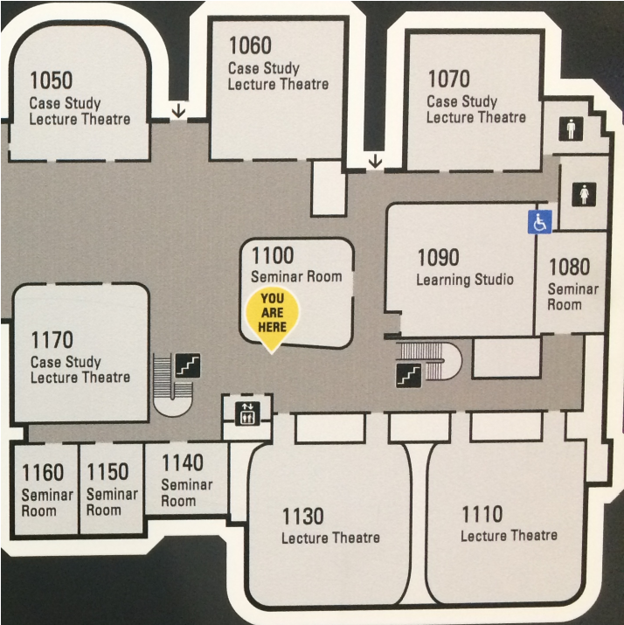

CONTINUERS
ABS Auditorium B2010
BEGINNERS
ABS Lecture Theatre 1110

EXTENSION

ABS Case Study Lecture Theatre 1050

Food around Campus

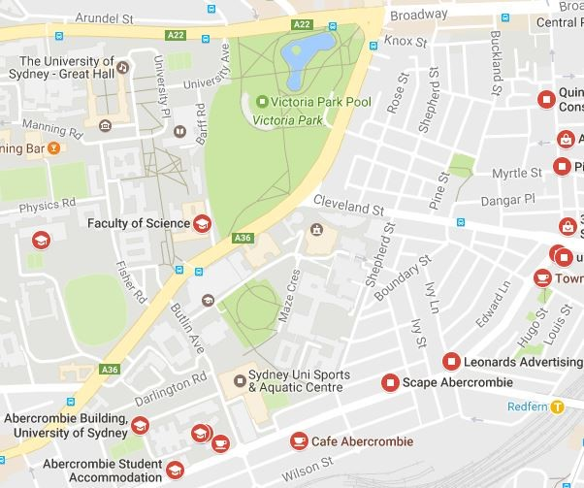
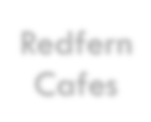
There will be food available at the Abercrombie Terrace Café in the ABS. There are also a number of food outlets located in the surrounding suburbs of Redfern (Abercrombie Street) and Newtown (King Street), as well as a food court in the nearby Broadway Shopping Centre.

Redfern
Broadway
Shopping
Centre
Redfern
Cafes

