NAFT Annual CONFERENCE 2021
Attendance Registration details for members

Dear Members,

Term 3 is coming to an end… What a strange few months this term has been!
As the return to school for students is now scheduled for the 25th October, the NAFT Annual Conference, on Saturday 23rd October, will be held via Zoom.
We would have loved the opportunity to offer it face to face so that we could mingle as we are desperate to socialise again...but it isn’t possible.
There will be no clash with French HSC marking as NESA has pushed back the HSC to Nov 9.
The conference will include our AGM.

The theme for 2021 is: Worldwide Collaborations in Languages

This year we are delighted to announce that we have an impressive list of guest speakers.

2 Keynote speakers from England have accepted to present during their night or very early morning for us!

- Joe Dale is a language consultant, recognised expert on technology and language learning, specialised in remote learning.
Could you please fill in this google form to choose the most interesting presentation from his wide range of presentations.
We will go with the majority of votes.

- Bruno Gomes is the author of the book :
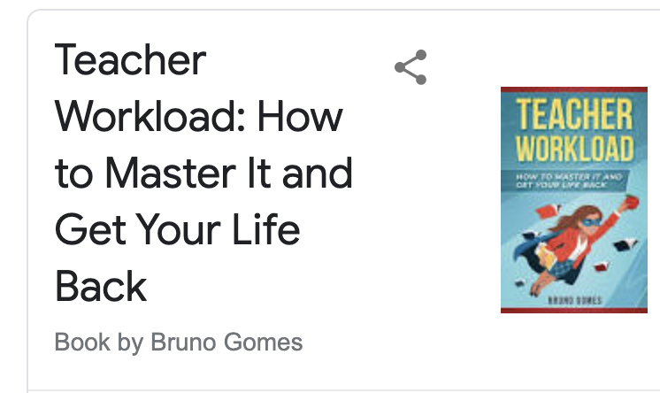

We thought both would be extremely useful as teachers find it harder and harder to cope with the demands of schools, the load of work and the paperwork.

It would be greatly appreciated if you could fill in this google form so that Bruno has a clearer idea of what you expect :
https://forms.gle/K5Tpy9iRt4JqFzPy7

Each of their presentations will be approximately one hour including question time.

- Other innovative presentations from members and associate members will include:

Nathalie MARCHAND | Progression ladder to be used as feedback/ student centered 1hour | From Melbourne
Sophie LERAT | Teach new book at IB High level  Salam Ouessant d’Azouz Begag 45mn | From Canberra
Colleen Barclay | Incorporating Aboriginal perspectives and histories in the language classroom 20mn | From Western Australia
Annabel Gassmann | Developing intercultural skills  In the language classroom a Yr 7 lesson  20 mn
Darija Egic | Breathing and mindfulness in the French classroom 20 mn
Fabian NAVARRO ( Ed. perfect)  Associate member | Differentiation without segregation  1 hour
Kelly HARRISON  ( Language Roadshow)  Associate member | Use CLIL in the French classroom  1 hour | From North NSW
Scott Cardwell  Associate member  ImmerseMe | using ImmerseMe in the classroom  1 h | from NZ
 | AGM
The conference will count as 5-6 hours of elective PD

What?: The NAFT Annual conference 2021 + AGM
When?: Saturday 23rd October : 8:50 - 4:15 (Times are TBC)
Where ?: Online via Zoom. Link TBAdvised.

REGISTRATION DETAILS
• Go to the NAFT website at: www.naft.org.au

• Fill in all your details as required when you click NAFT CONFERENCE under –
Upcoming Events on the right-hand side of the home page.

• Knowing how tough the year has been, we are offering this conference at a discounted price. The cost of the conference is only $90.00. Take advantage of this wonderful opportunity.
We advise you to start your registration process ASAP.

Note: DET Schools;
You are able to pay via PCARD payment. Ask your Finance Administration about this.

Closing date for registration is Monday 18th October 2021

Zoom link(s), final conference program & AGM agenda will be sent a few days prior to the conference.

Important UPDATE From NAFT

NAFT is once again intending to offer subsidies for the January Immersion course with substantial accreditation hours at Alliance Française in 2021. Details will be elaborated at the conference.

So… REGISTER NOW & put the DATE in your diary:
NAFT Annual conference and AGM - Saturday 23 October 2021

Donc inscrivez-vous sur le site-web de la NAFT www.naft.org.au

Merci beaucoup,
Annabel Gassmann and Bev Wilkinson
NAFT Co-presidents 2021

