EXCITING NEW WORKSHOP!
“Sac à malices” - classroom ideas for Stage 4 French

This interactive workshop aims to add to your ‘trick bag’ for teaching the 100 compulsory hours in Stage 4, with the aim of promoting student attention and retention.

Adele Walker will share and model a range of learning materials that have been developed to engage Stage 4 students in their learning. Participants will have the opportunity to ‘road test’ activities that have proven successful in a range of settings, can be adapted to various topics and provide opportunities for differentiation. They will have access to the modelled resources and be able to customise them to suit the learning needs, interests and prior learning of their own students.

Adele has been teaching French for more than 15 years, across a diverse range of schools in Australia and overseas. She currently works at Fort St HS alongside tutoring pre-service teachers at UNSW.

Duration: 2 hours

Time: 1.30 pm-3.30 pm Please arrive at 1 pm in order to sign in
Venue: Fort St High school, Parramatta Rd, Petersham

Date: 22 June 2022
Cost : $ 80

NESA accreditation is being sought for this workshop.

Map: How to get there?
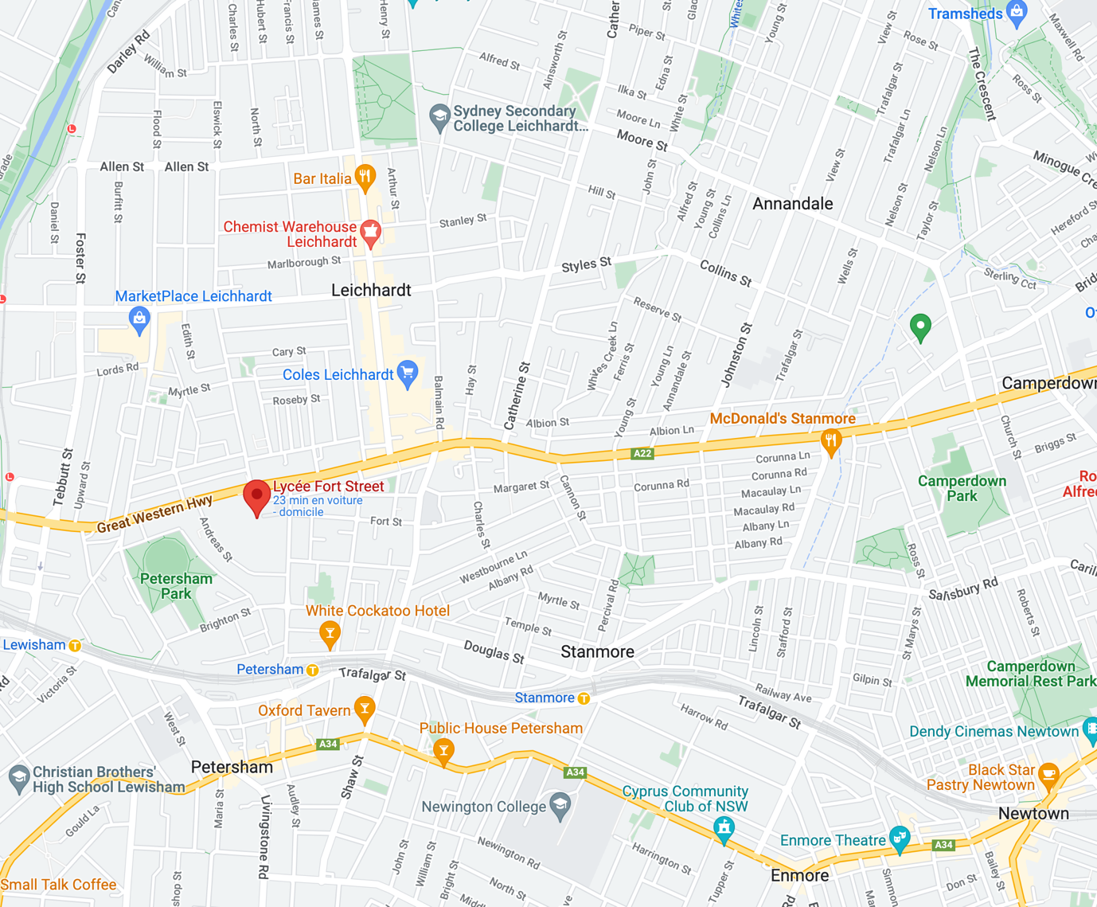

In order to enrol for this workshop, click on the link on our website www.naft.org.au on the right-hand side.
Registrations close on June 13.
Venez-y nombreux !
Annabel Gassmann
Présidente NAFT 2022

