NAFT Annual CONFERENCE 2022
Attendance Registration details for members

Dear Members,

The NAFT Annual Conference will take place at NSW school of languages, 35 West St, Petersham on Saturday 22nd of October from 10.30 am to 4.30 pm.
The conference will include our AGM.
The NSW school of languages is easily accessible via public transport.

The theme for 2022 is: Worldwide Collaborations in Languages

This year we are delighted to announce that we have an 2 outstanding keynote speakers

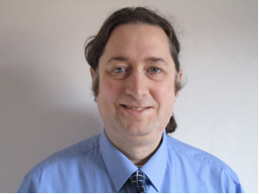
- Joe Dale is a language consultant, recognised expert on technology and language learning, specialised in remote learning.

- Bruno Gomes is the author of the book :
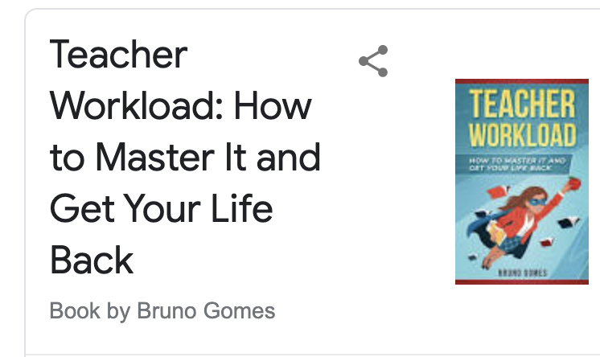

We thought both would be extremely useful as teachers find it harder and harder to cope with the demands of schools, the load of work and the paperwork.

Each of their presentations will be approximately one hour including question time.

- Other innovative presentations from members and associate members will include:

- developing intercultural skills, a practical lesson
- “Sac à malices”, useful strategies in the Yr 8 classroom to keep students engaged
- using Immerseme to develop Speaking skills
- presentations from Hachette/ Clé international/Intext
Technology in the classroom (QR Codes, Virtual Reality, Green Screens and more)
- Motivating boys in the language classroom.
- Gamifying Education. (How to turn your classroom into a Role Playing Game)
- Fun, visual ways to do Assessment For Learning.
- Fun with Drilling. (fun activities to practice and drill vocab)

- Teaching French often means teaching a wide variety of levels in one classroom and differentiating effectively can be a real challenge. This session will explore the benefits of putting in place a progression-based student-centered program in French. You will discover how such a program can support you in your effort to provide students with more personalised lessons, support their growth while giving them a sense of achievement, agency and boost their motivation. You also will engage in practical and trialled examples showing you how easily you can implement relevant and meaningful differentiation and enable students to take ownership of their own learning and actively engage them in the feedback process for improvement.

The conference will count as 5 hours of elective PD
We are still finalising the programme.

What?: The NAFT Annual conference 2022 + AGM
When?: Saturday 22 October : 10.30-4.30pm
Where ?: NSW school of languages, Petersham

REGISTRATION DETAILS
• Go to the NAFT website at: www.naft.org.au

• Fill in all your details as required when you click NAFT CONFERENCE under –
Upcoming Events on the right-hand side of the home page.

• The cost of the conference is $120.00. We advise you to start your registration process ASAP.

Note: DET Schools;
You are able to pay via PCARD payment. Ask your Finance Administration about this.

Closing date for registration is Monday 17th October 2022

Final conference program & AGM agenda as well as vacancies will be sent two weeks prior to the conference.

Important UPDATE From NAFT

NAFT is once again intending to offer subsidies for the January Immersion course with substantial accreditation hours at Alliance Française in 2023. Details will be elaborated at the conference.

Donc inscrivez-vous sur le site-web de la NAFT www.naft.org.au

Merci beaucoup,
Annabel Gassmann NAFT president 2022

